***Practical 1:***

***Introduction to arduino (Blinking led***)

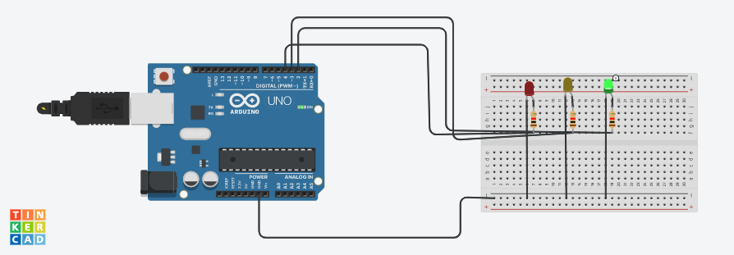

***Practical 2:***

***Program using Light sensitive sensor***

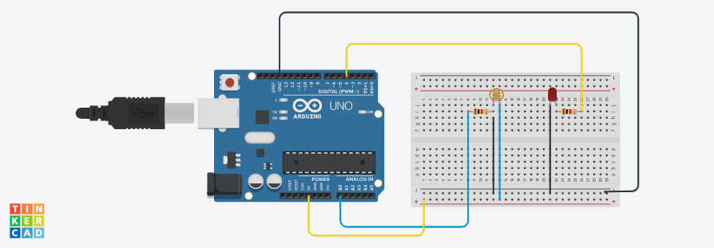

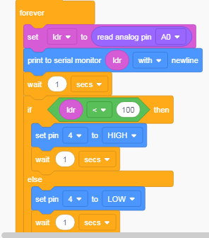

// C++ code

//

int ldr = 0;

void setup()

{

pinMode(A0, INPUT);

Serial.begin(9600);

pinMode(4, OUTPUT);

}

void loop()

{

ldr = analogRead(A0);

Serial.println(ldr);

delay(1000); // Wait for 1000 millisecond(s)

if (ldr < 100) {

digitalWrite(4, HIGH);

delay(1000); // Wait for 1000 millisecond(s)

} else {

digitalWrite(4, LOW);

delay(1000); // Wait for 1000 millisecond(s)

}

}

***Practical 3:***

***Program using Temprature sensor***

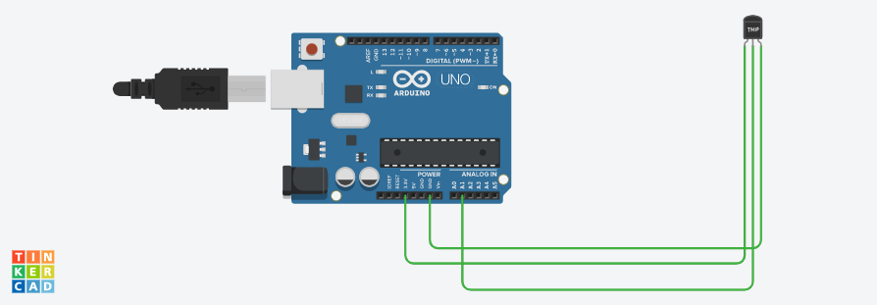

// C++ code

//

float celsius;

int temp = A1;

void setup()

{

pinMode(temp,INPUT);

Serial.begin(9600);

}

void loop()

{

celsius = analogRead(temp)*0.004882814;

celsius = (celsius - .05)*100.0;

Serial.print(celsius);

Serial.println("c");

delay(1000);

}

***Practical 4:***

***Program using humidity sensor***

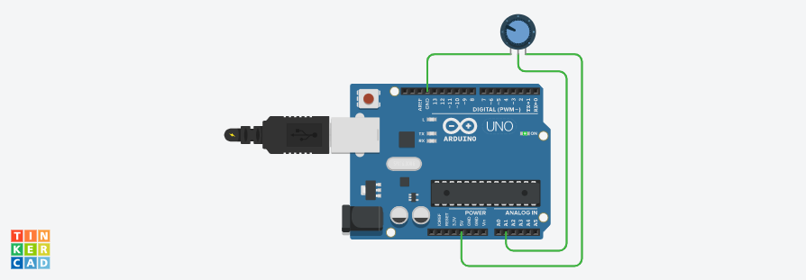

// C++ code

//

float humidity;

int humidityPin = A1;

void setup()

{

Serial.begin(9600);

}

void loop()

{

humidity = analogRead(humidityPin);

Serial.print("Humidity");

Serial.print(map(humidity,0,1023,10,70));

Serial.println("%");

delay(1000);

}

Practical 6:

Program using ultrasonic sensor

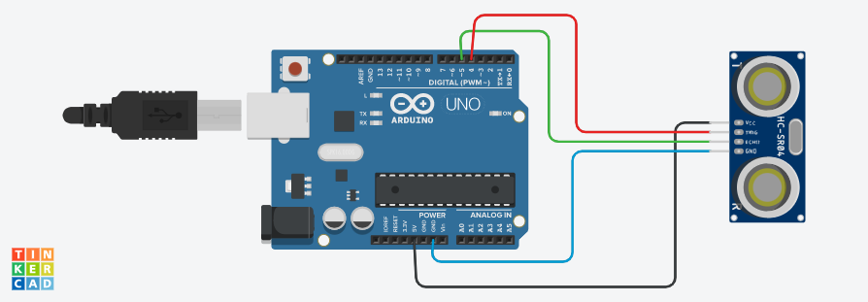

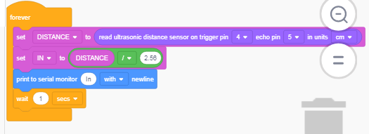

// C++ code

//

int ULTRASONIC = 0;

int DISTANCE = 0;

int IN = 0;

long readUltrasonicDistance(int triggerPin, int echoPin)

{

pinMode(triggerPin, OUTPUT); // Clear the trigger

digitalWrite(triggerPin, LOW);

delayMicroseconds(2);

// Sets the trigger pin to HIGH state for 10 microseconds

digitalWrite(triggerPin, HIGH);

delayMicroseconds(10);

digitalWrite(triggerPin, LOW);

pinMode(echoPin, INPUT);

// Reads the echo pin, and returns the sound wave travel time in microseconds

return pulseIn(echoPin, HIGH);

}

void setup()

{

Serial.begin(9600);

}

void loop()

{

DISTANCE = 0.01723 * readUltrasonicDistance(4, 5);

IN = (DISTANCE / 2.56);

Serial.println("In");

delay(1000); // Wait for 1000 millisecond(s)

}

***Practical 7:***

***Program using Digital infrared motion sensor***



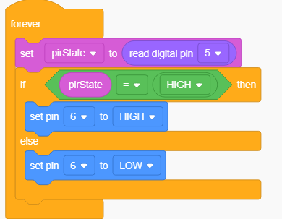

// C++ code

//

int pirstate = 0;

void setup()

{

pinMode(5, INPUT);

pinMode(6, OUTPUT);

}

void loop()

{

pirstate = digitalRead(5);

if (pirstate == HIGH) {

digitalWrite(6, HIGH);

} else {

digitalWrite(6, LOW);

}

delay(10); // Delay a little bit to improve simulation performance

}

***Practical 8:***

***Program using Gas sensor***

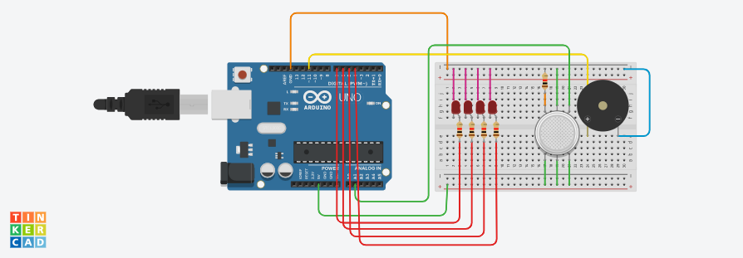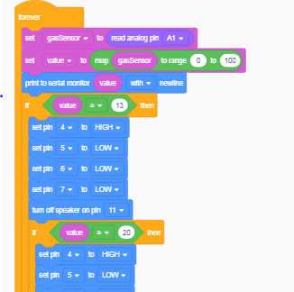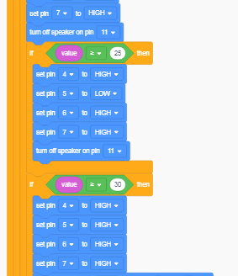

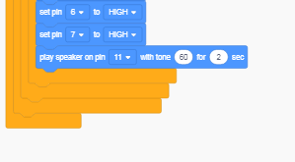

***Practical 9:***

***Program using servo motor***

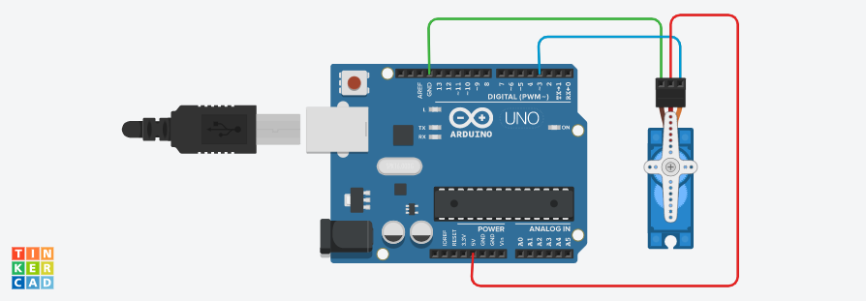

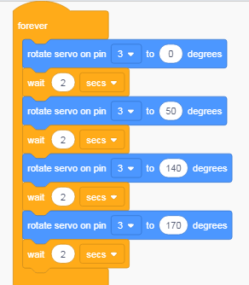

***Practical 10:***

***Program making joystick with arduino***

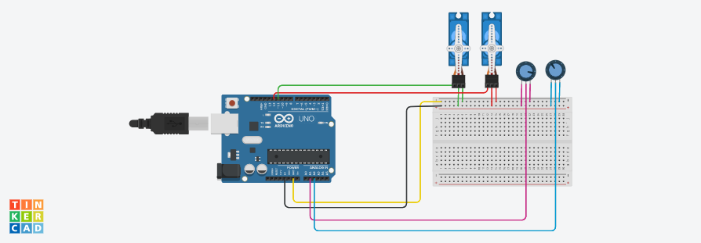

#include <Servo.h>

int ServoHorizontalPin = 11;

int ServoVerticalPin = 12;

int HorizontalPotPin = A0;

int VerticalPotPin = A1;

int ServoH_Min = 0;

int ServoH_Max = 180;

int ServoV_Min = 0;

int ServoV_Max = 180;

Servo HorizontalServo;

Servo VerticalServo;

int HorizontalPotValue;

int HorizontalServoPosition;

int VerticalPotValue;

int VerticalServoPosition;

void setup()

{

HorizontalServo.attach(ServoHorizontalPin);

VerticalServo.attach(ServoVerticalPin);

Serial.begin (38400);

}

void loop()

{

HorizontalPotValue = analogRead (HorizontalPotPin);

Serial.print(HorizontalPotValue);

VerticalPotValue = analogRead (VerticalPotPin);

Serial.print (VerticalPotValue);

HorizontalServoPosition= map (HorizontalPotValue,0,1023,ServoH_Min,ServoH_Max);

VerticalServoPosition=map (VerticalPotValue,0,1023,ServoH_Min,ServoH_Max);

HorizontalServo.write(HorizontalServoPosition);

delay(20);

}